Lab Exercise 6.1
Managing Jenkins Freestyle Jobs

Objective: To manage Jenkins job by creating, renaming, and deleting freestyle job, facilitating streamlined job configuration and maintenance within the Jenkins environment

Tools required: Jenkins

Prerequisites: None

Steps to be followed:
- Create a new Freestyle Job
- Rename and delete the FreeStyle Job

Step 1: Create a new Freestyle Job

- Open the browser, go to the Jenkins Dashboard by typing localhost:8080 in your browser, provide the credentials, and click the Sign in button

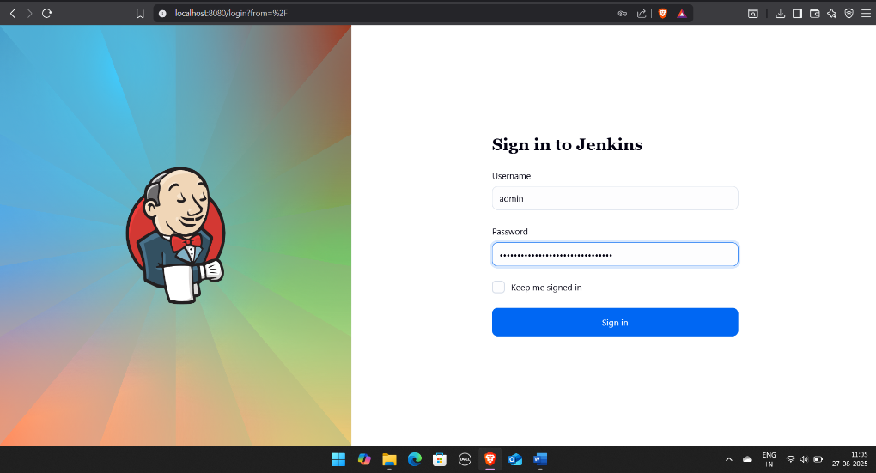
Note: The credentials for accessing Jenkins in the lab are Username: admin and Password: admin.

- Click on New Item in the Jenkins Dashboard

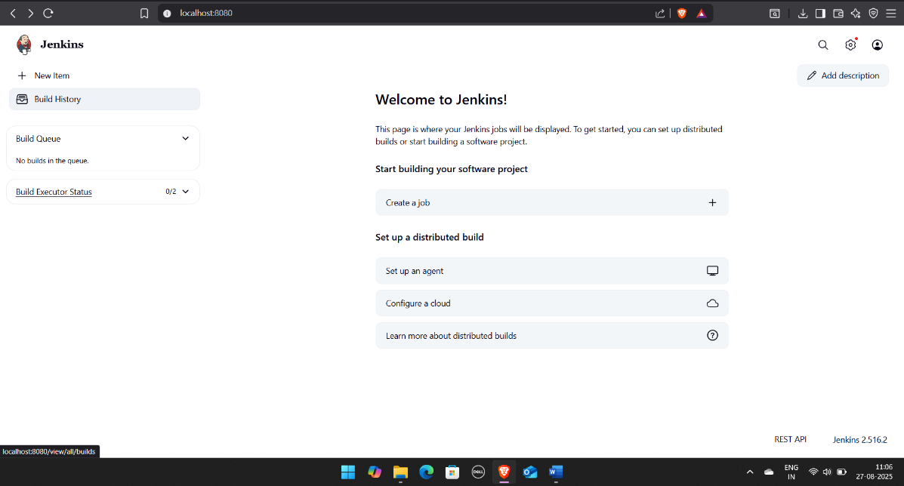

- Enter a name for your project, select Freestyle project as the build job type, and click
on OK
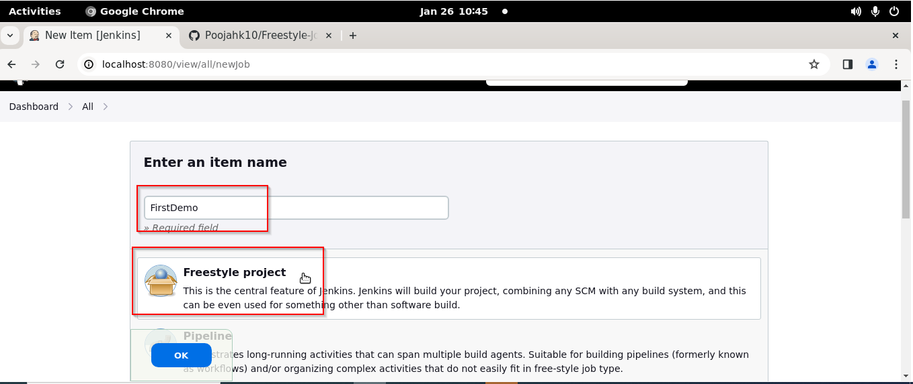

- Click on Save

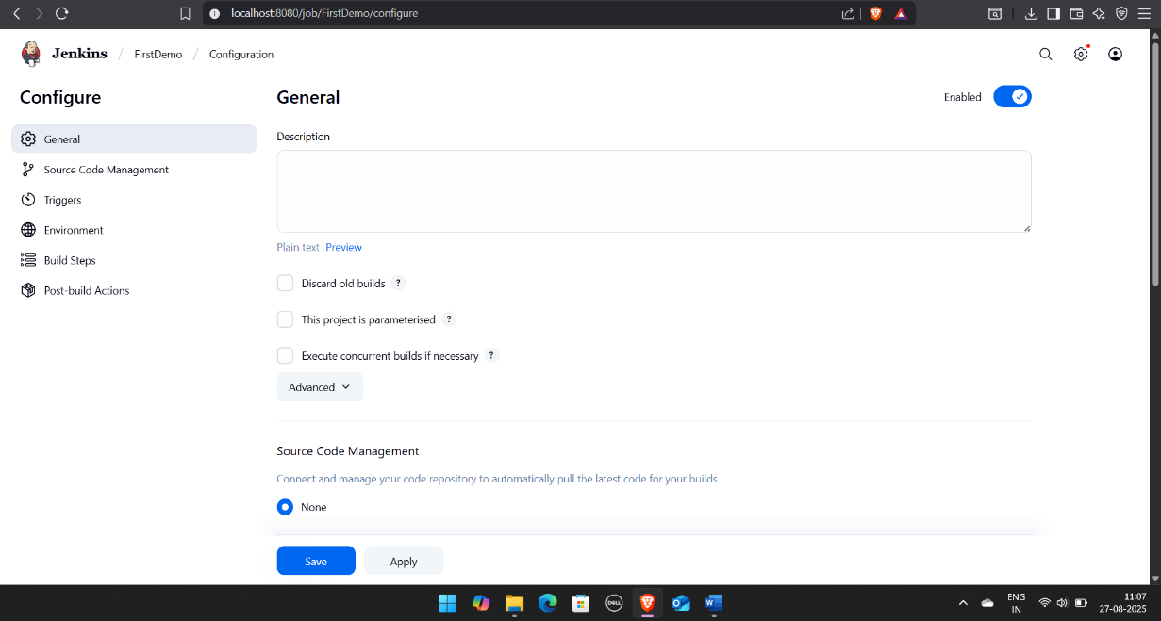

Step 2: Rename and delete the Freestyle Job

- Click on the name of the project that you have created as shown in the screenshot below:

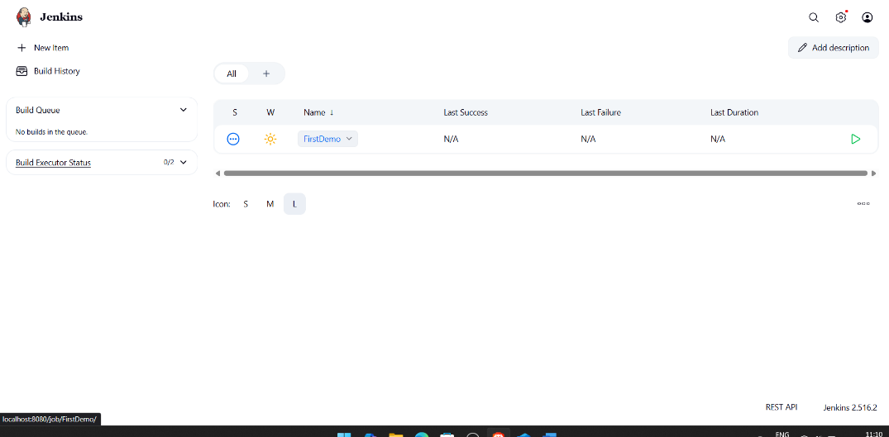

- Click on the Rename button to rename the project

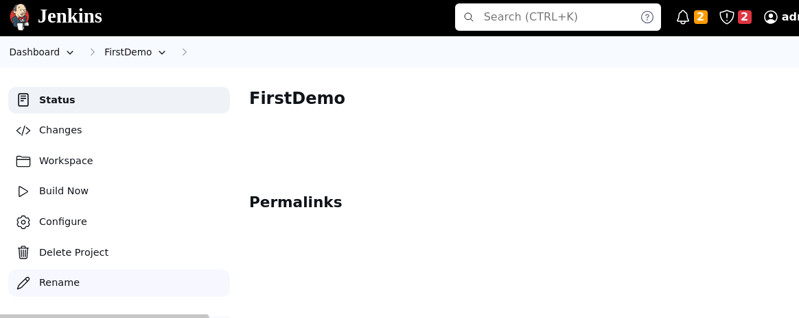

- Enter a desired name to the project and click on Rename

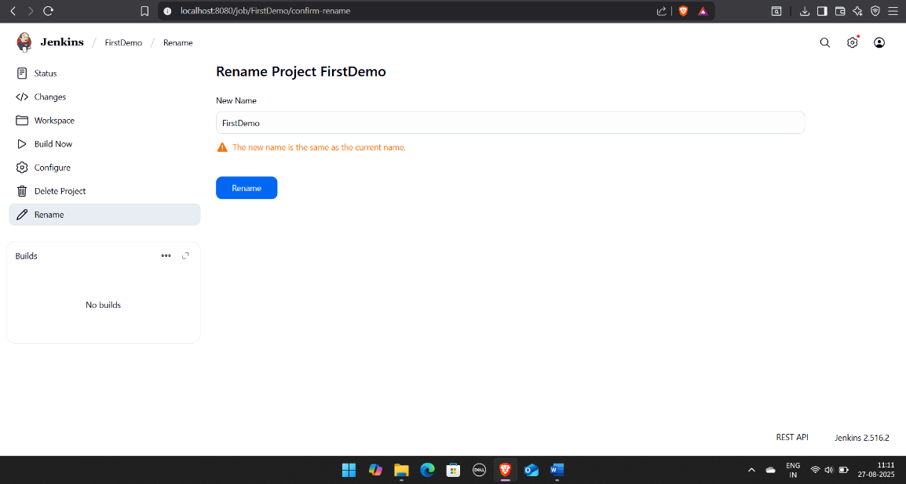

- Click on the renamed project and then click on Delete Project to delete the project

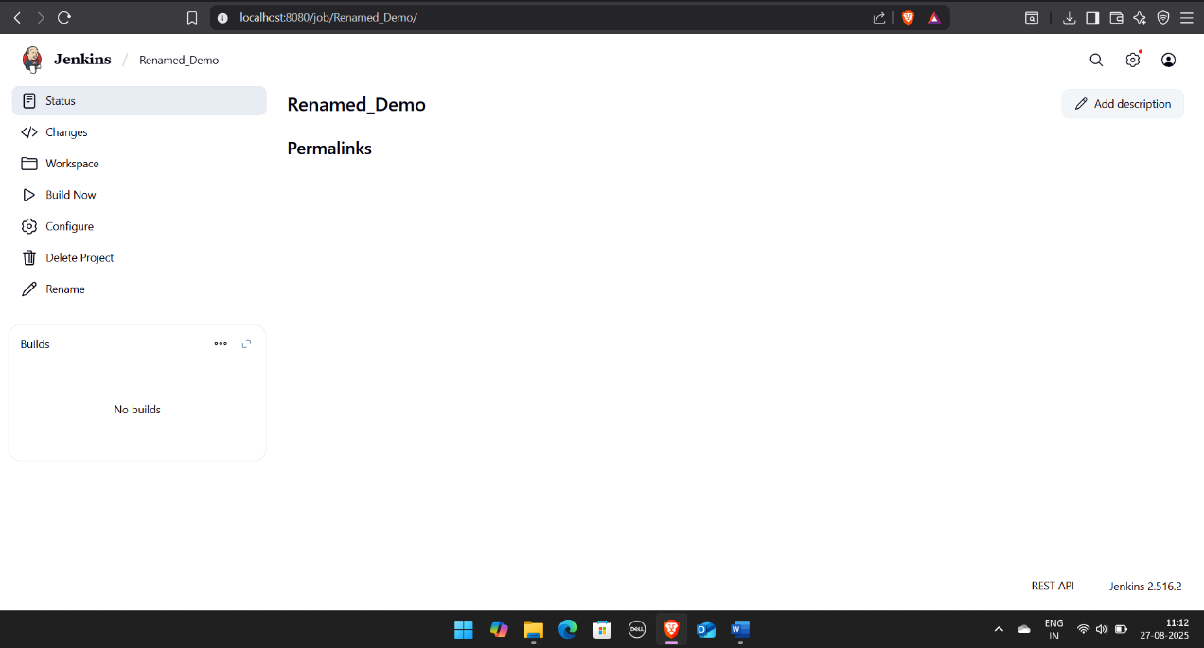

By following these steps, you have successfully managed Jenkins jobs by creating, renaming, and deleting Freestyle Job, streamlining your project workflows within the Jenkins environment.
